First download the compressed file and unzip it on location

Now open command prompt and go to <elasticserach_home>/bin path

Set JAVA_HOME if it is not set

Run command elasticsearch

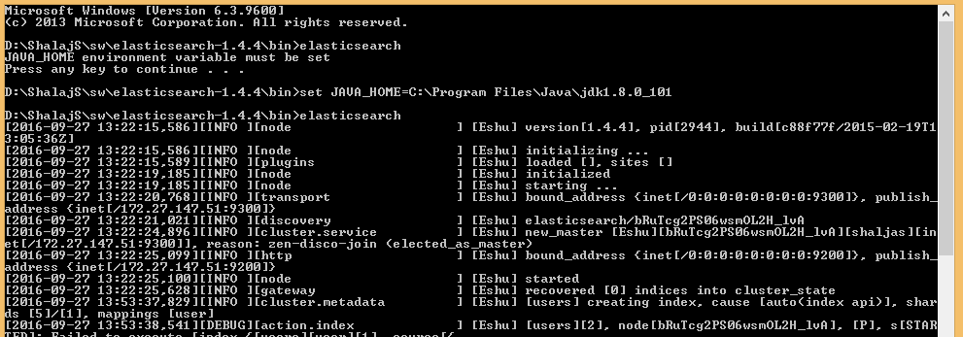

This will start your server; this will listen on default port 9200, this work as REST API so we can call REST on port 9200 without creating and deploying any war file

Elasticsearch – Key Concepts

The key concepts of Elasticsearch are as follows −

* **Node** − It refers to a single running instance of Elasticsearch. Single physical and virtual server accommodates multiple nodes depending upon the capabilities of their physical resources like RAM, storage and processing power.
* **Cluster** − It is a collection of one or more nodes. Cluster provides collective indexing and search capabilities across all the nodes for entire data.
* **Index** − It is a collection of different type of documents and document properties. Index also uses the concept of shards to improve the performance. For example, a set of document contains data of a social networking application.
* **Type/Mapping** − It is a collection of documents sharing a set of common fields present in the same index. For example, an Index contains data of a social networking application, and then there can be a specific type for user profile data, another type for messaging data and another for comments data.
* **Document** − It is a collection of fields in a specific manner defined in JSON format. Every document belongs to a type and resides inside an index. Every document is associated with a unique identifier, called the UID.
* **Shard** − Indexes are horizontally subdivided into shards. This means each shard contains all the properties of document, but contains less number of JSON objects than index. The horizontal separation makes shard an independent node, which can be store in any node. Primary shard is the original horizontal part of an index and then these primary shards are replicated into replica shards.
* **Replicas** − Elasticsearch allows a user to create replicas of their indexes and shards. Replication not only helps in increasing the availability of data in case of failure, but also improves the performance of searching by carrying out a parallel search operation in these replicas.

You can use any REST Tool to test it (Fiddler web debugger, SOAP UI, Postman plugin for chrome,)

1. First we are creating some document or inserting some values by rest call

Put request for <http://localhost:9200/users/user/1> as json input

|  |
| --- |
| {  "first_name": "shalaj",  "last_name": "shukla",  "rating": "4.3",  "Designation": "SA"  } |

Put request for <http://localhost:9200/users/user/2> as json input

|  |
| --- |
| {  "first_name": "anuj",  "last_name": "shukla",  "rating": "3.3",  "Designation": "SE"  } |

Put request for [http://localhost:9200/users/user/3](http://localhost:9200/users/user/3%20) as json input

|  |
| --- |
| {  "first_name": "aaaa",  "last_name": "bbbb",  "rating": "3.9",  "Designation": "SE"  } |

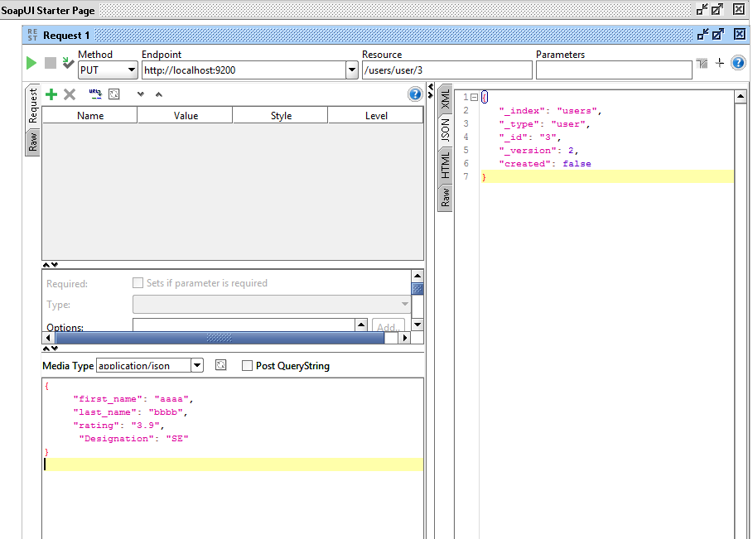

By this way we put three records in user

In elastic search terms we say users as index and user as type

In database terminology we can think users as schema and user as table

We can now search the records by do the rest call on URL below

<http://localhost:9200/users/user/_search>

we need to submit POST request and pass input as below

|  |
| --- |
| {  "query" :{  "match_all" :{}  }    } |

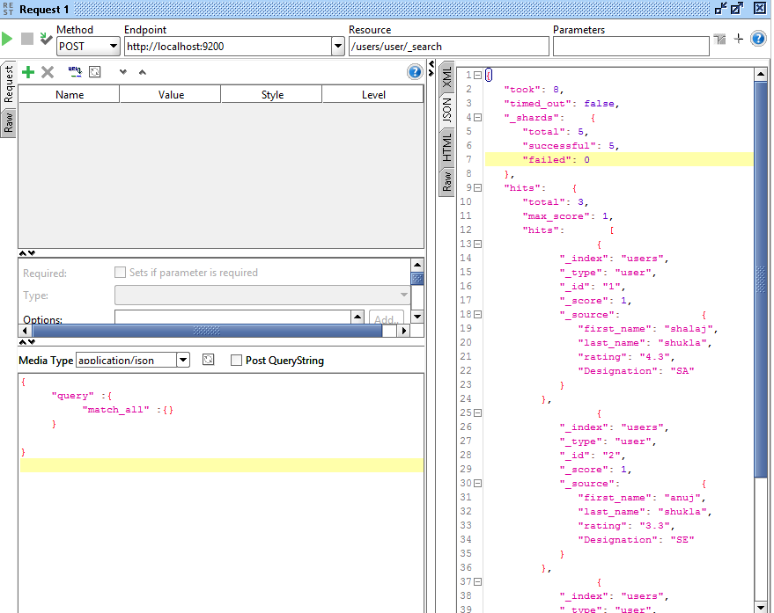

Or we can use get request without passing json

<http://localhost:9200/users/user/_search>

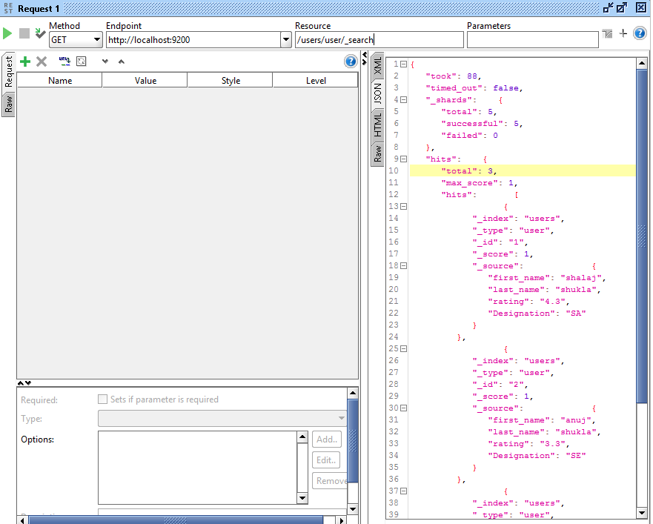

Get request to search “Shalaj” in whole documents any where

<http://localhost:9200/users/user/_search?q=shalaj>

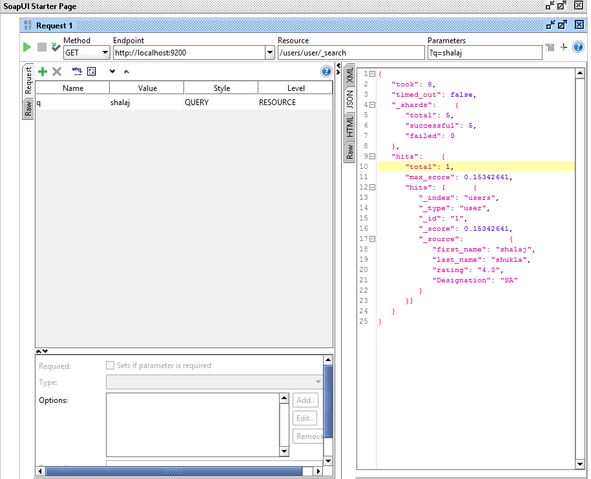

Or if we want to search on particular field we can do like below

[http://localhost:9200/users/user/_search?q=(first_name:"shalaj")](http://localhost:9200/users/user/_search?q=(first_name:%22shalaj%22))

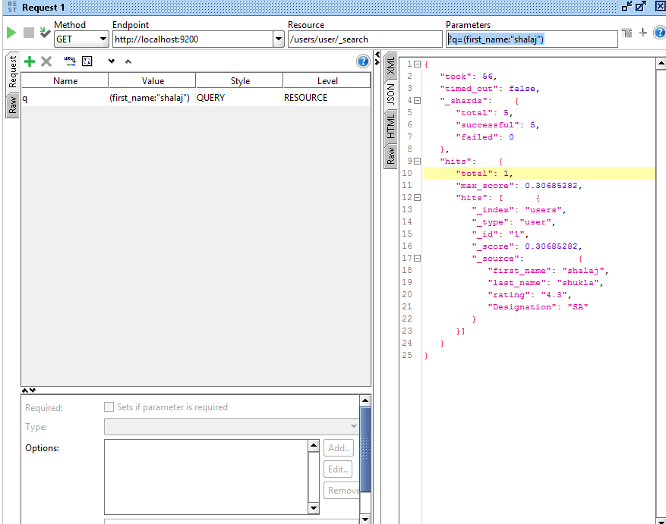

[http://localhost:9200/users/user/_search? q=(first_name:"shalaj" or rating <4)](http://localhost:9200/users/user/_search?%20q=(first_name:%22shalaj%22%20or%20rating%20%3c4))

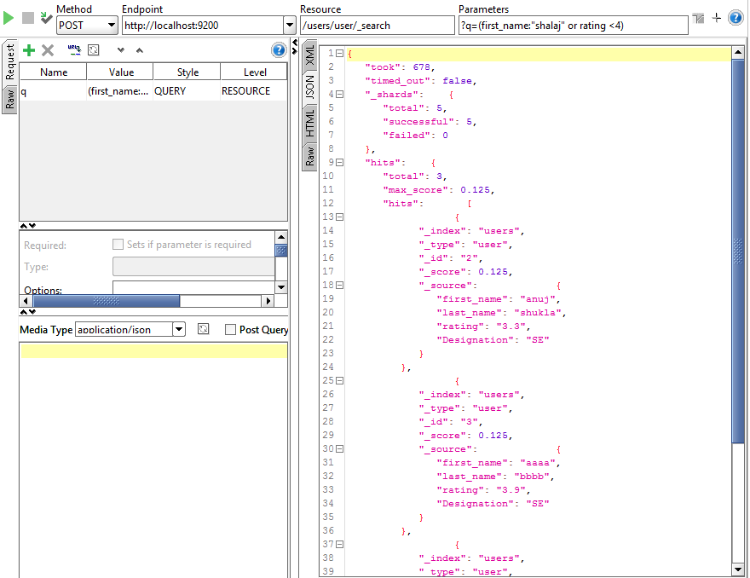

To check the health of cluster

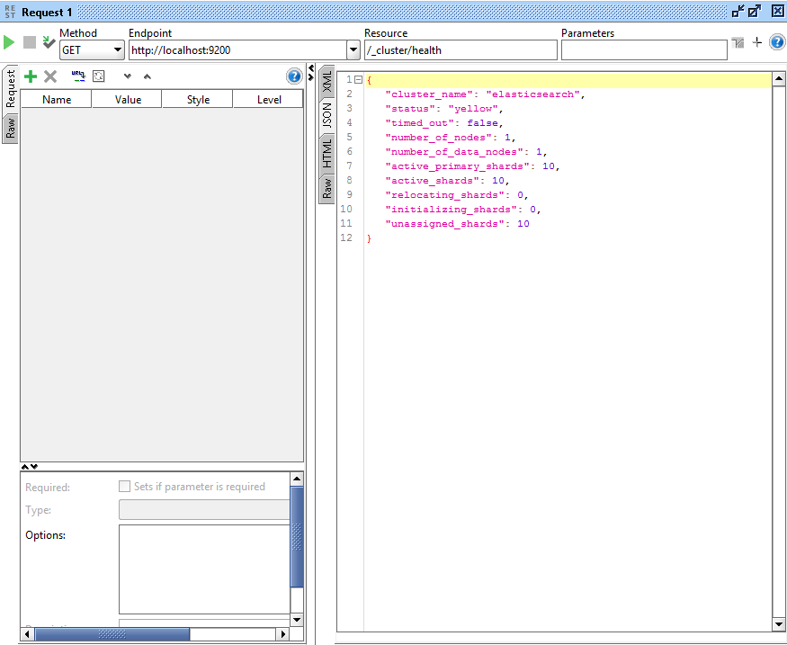

To get the Node info

